Chapter 16, Solution 38.

The switch in the circuit of Fig. 16.61 is moved from position a to b (a make before break switch) at t = 0. Determine i(t) for t > 0.

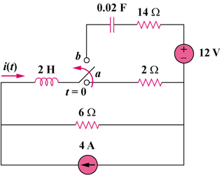
Figure 16.61
For Prob. 16.38.

Solution

Step 1. We first determine the initial conditions. We assume that v_{C}(0) = 0 since we are not given otherwise. i(0) = [4(2x6)/(2+6)]/2 = 3 amps. Next we need to convert the circuit for t > 0 into the s-domain converting the current source in parallel with the 6Ω into a voltage source in series with 6Ω.

I

12/s
+ −

20 Ω

50/s

3/s

2s

I

14 Ω

I

24/s

12/s

+
−
+ −

6 Ω

50/s

3/s

2s

Using the simplified circuit on the right, 2s(I–3/s) + [50/s]I –(12/s) +20I = 0. Now we solve for I, perform a partial fraction expansion, and then convert into the time domain.

Step 2. [2s+(50/s)+20]I = 6+12/s = [(s²+10s+25)/(0.5s)]I = 6(s+2)/s or
I = [3(s+2)/(s+5)²] = [A/(s+5)] + [B/(s+5)²] where As+5A+B = 3s+6 or
A = 3 and B = –5A+6 = –15+6 = –9. Thus,

i(t) = [(3–9t)e^{–5t}]u(t) amps.

